2026 CUPE 716
Scholarship Application Instructions
If you have a child who is graduating from Secondary School in 2026, your child may wish to apply for a scholarship from your union, CUPE Local 716. This year we have a total of four (4) $1000 scholarships available for the children of CUPE 716 members: two for Academic, one for Trades, and one for Fine Arts.

To apply, please make a copy of the Application Form which accompanies this message. Complete the application and mail or deliver the completed form to the union office, together with these two items only:

- A sealed Diploma Verification Report (if the school is on MyEd) or a sealed transcript of marks and the most recent report card (if the school is not on MyEd)
- A covering letter
Any other attachments will be disregarded
All completed Scholarship Applications can be submitted via:

Canada Post:
CUPE Local 716
PO Box 36522 Seafair Post Office Richmond BC, V7C5M4
Delivered by hand or via interoffice mail CUPE Local 716
Sea Island School, Room 8 (upstairs)
1891 Wellington Crescent Richmond, BC, V7B 1G6

It is very important that you notice the Deadline Date.
If sending by Canada Post it must be postmarked by April 17, 2026, if delivering by hand or by courier, it must be delivered to the Union Office before 2:00pm on April 23, 2026
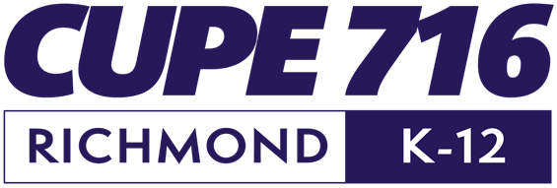
CUPE 716 Trustees will consider all applications when making the final decision, and successful candidates will be informed on or before May 29, 2026


Richmond School Board Employees’ Union
CUPE Local 716
Scholarship Application 2026
- To be eligible for a CUPE 716 Scholarship, one of the applicant’s parents or legal guardian must be a member of CUPE Local 716.
- This round of scholarships is intended for students graduating in June of 2026
- Four Scholarships each will be awarded. Two scholarships are for academic ability, one for Trades, and one for Fine Arts. One of the academic scholarships is known as the Reynold Sokolik Memorial Scholarship and one of the Trades/Fine Arts scholarships is known as the Wally Wenn Memorial Scholarship.
- An awarded scholarship can be held in trust for up to three (3) years.
- To redeem a scholarship the winner must provide proof of payment to a post-secondary education institution.
- The final selection will be made by CUPE 716 Trustees, and the successful candidates will be notified on or before May 29, 2026

Name of applicant:
Name of School you are currently attending:
Birthdate (dd/mm/yy):

Street Address:
City, Postal Code:
Telephone #: Email:
Do you volunteer at your school or In your community? If so, what do you do?

What activities do you participate in your school or community?

What are your plans for future education/career?

Name of your parent or guardian who is a member of CUPE 716:
Please attach two things only to this application. Any other attachments will be disregarded
- a sealed Diploma Verification Report (if the school is on MyEd) or a sealed transcript of marks and the most recent report card (if the school is not on MyEd)
- a covering letter

Hand Deliver (9:00-1:00 T, W, TH) to:
CUPE Local 716
1891 Wellington Crescent
Sea Island School, Room 8 (upstairs) Richmond BC, V7B 1G6

Via Canada Post to:
CUPE Local 716
PO Box 36522 Seafair Post Office Richmond BC, V7C1V0

Mailed applications must be postmarked by April 17, 2026, and hand-delivered applications must be received at the Union office before 2:00 pm on April 23, 2026

